Facebook “Birthday Cash” Method

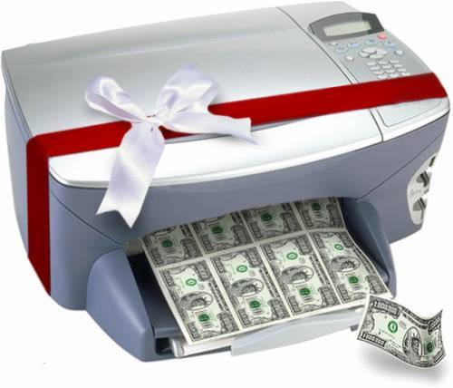

Make $50+ A Day With “The Birthday Cash Method”
Imran Naseem

Thankyou for purchasing my latest CPA Cash cow report on making money from CPA Marketing.
In this report I will show you a simple powerful method on how you can make money using the Birthday Facebook Cash method.
This is a very controversial method; but is very powerful once you use it. I can assure you that you will not get banned from applying this method.
This method involves cashing in on “people’s birthdays” and taking advantage of the Birthday “Buzz”. In order for you to apply this strategy you will need to be a member of several CPA Networks.
There are lots of CPA Networks out there.
I hope you enjoy this report and start using the methods to make money.
Imran Naseem

Getting Started
I am going to dive straight into this method and show you the blueprint on how to make money from the Birthday Cash Method.
Now as you know everyone has birthdays. Since we were kids to our dying day we all have a chance to celebrate our birthdays. This is one day which gives each of us a chance to feel really “special” and loved by our loved ones.
This method involves cashing in on Birthday’s by getting people to fill out your CPA offer for you.
So the first thing to do is head over to Facebook.com and open a brand new Facebook account – with a female name.
Now when it comes to creating your Facebook account make sure you use an authentic name that does not sound spammy or anything.

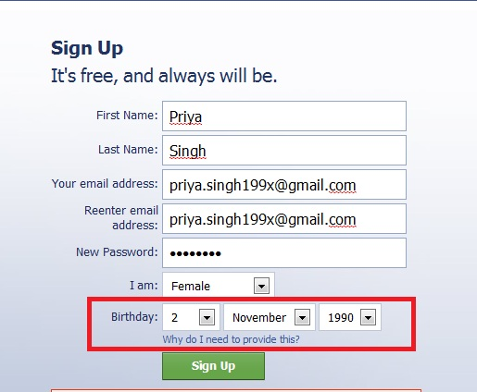

As you can see I am going to be using Gmail to create and activate this Facebook account and you should notice that I am going to set a date that is close to the “birthday” of this account. So for example, once the account is created and activated people will be able to leave messages on my wall to say “Happy Birthday”.

Once you have activated your account and created it you will need to find an image that you can use.
Now when it comes to images you can use many different methods. If you want to use greyhat methods you simply head over to Google images and find pictures of “females”.
However, these days that is easily detectable or you can head over to hotornot.com and grab a few pictures of some females – but that will be copyright.
The best thing to do is head over to my favourite website Fiverr.com and type in “sexy images” and see what comes up

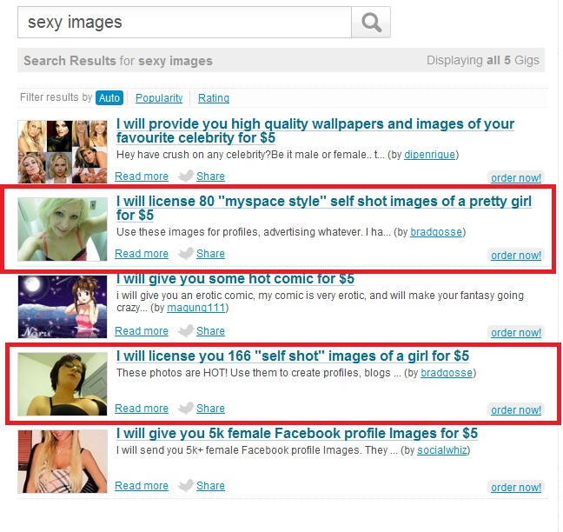

As you can see several Gigs show up that offer services that allow you to “license images”. This means these images do not break copyright and you are free to use them on your Facebook profile.
Here is a Gig from Internet Marketer Brad Gosse that lets you license 80 “self shot” images of a pretty girl.

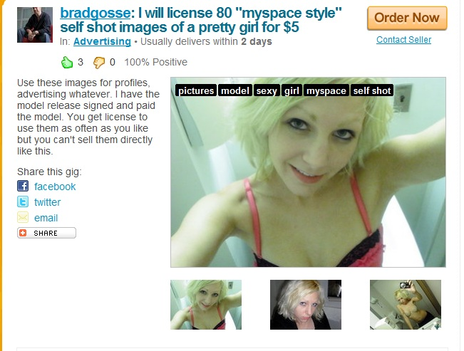

As you can see you are free to use these images for your Facebook profile and advertising. Also you will not get into trouble with your CPA Networks when it comes to promoting their offers as these images are real and have a “license”.

Here is another Gig that you can use from the same guy.

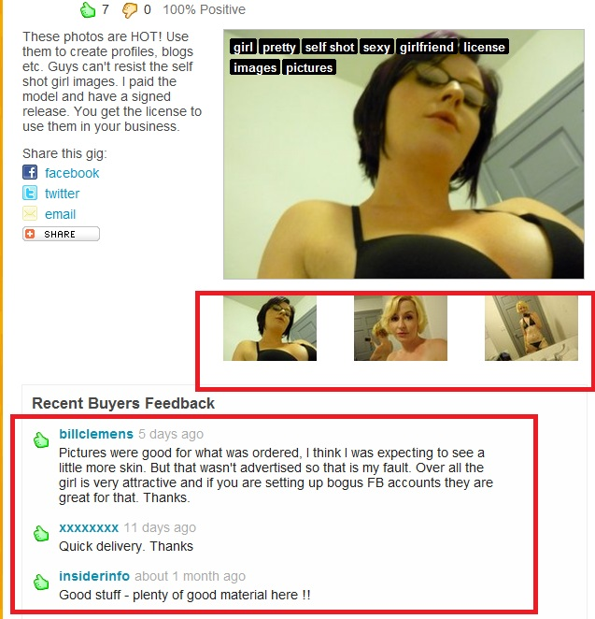

As you can see this guy has had excellent feedback from these images and people are happy to pay $5.00 for these.
Once you have the images the next thing to do is go back to your Facebook profile you created and simply upload the image.
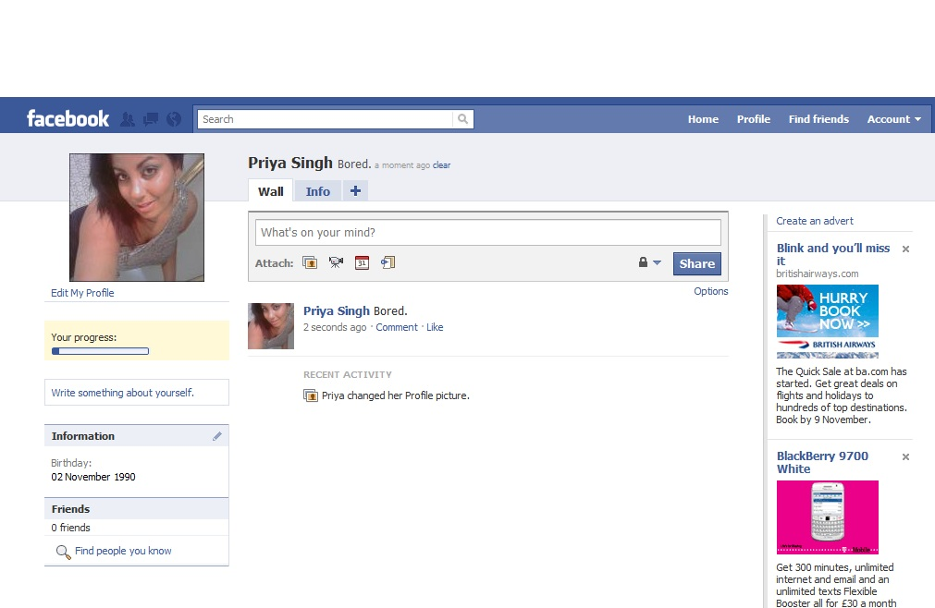

As you can see at this stage I have zero friend – so now what I am going to do is simply outsource this part by getting as many friends as possible to my Facebook profile.
The best site for this is Fiverr.
Here are the following Gigs on Fiverr I highly recommend that will get you lots of friends in no time.
Here is ONE gig that you can use to get lots of Facebook friend requests in a short space of time.

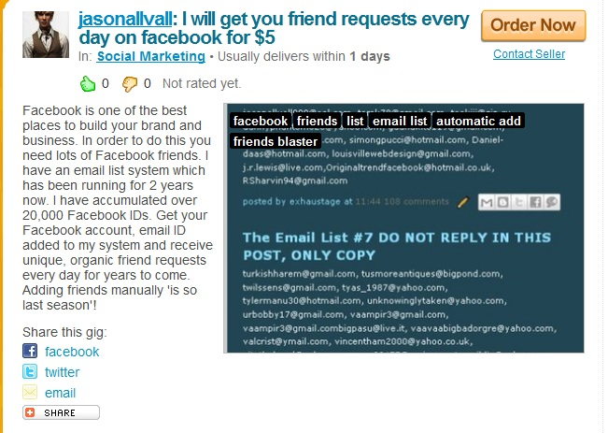

This is a pretty good Gig you can use. This guy has a big email list system and by using this Gig you can receive unique friend requests on complete Autopilot.
Here is another Gig that allows you to get lots of friends to your Facebook profile in a short space of time.
You can also head over to Odesk where you can hire people to get you lots of Facebook friends in a short space of time. I recommend you ask for “male friends” only since we are going to be promoting CPA dating offers to our Facebook list.
Here is an example of a typical job description you can use.

“I have a female Facebook profile and I need lots of “real” male friends to my profile in a short space of time. These accounts must be real and must not get the account banned. I am looking to hire someone on a long-term basis if you can do a good job. These friend requests must be from the UK and USA only.”

Once you have posted your listing on Odesk and ordered a few Gigs on Fiverr I would then wait until your account has hundreds and hundreds of friends.
Once your account has lots of friends simply edit your profile and make sure your account has at least several different pictures of the “female”. This will not only make it authentic in the eyes of your friends but it will make it realistic.
The next thing to do is then simply update your Facebook status to something like
“Im bored. Going gym soon and hoping to have a nice relaxing meal”.
Now going back to the “Birthday method” remember when I told you to create the account on a certain date you will get people commenting on your wall?
For example, if you created the account on the 4th November 2010 and you set the “birthday” to 7th November 1989 then you have at least 3 days to prepare for the “Birthday” by adding lots of friends in a short space of time.
Once you have lots of friends it will show up as “your birthday” on their page (on the right hand side).

Eventually you will have people leave comments on your wall that will say something like : -
“Happy Birthday darling, hope you have a nice day” etc.
Now this is the best time to cash in.
When you have a certain amount of people the next thing to do is make a “list” of your friends on Facebook so it would be easy to message them.
You do this by clicking on the “edit friends” option on your profile.

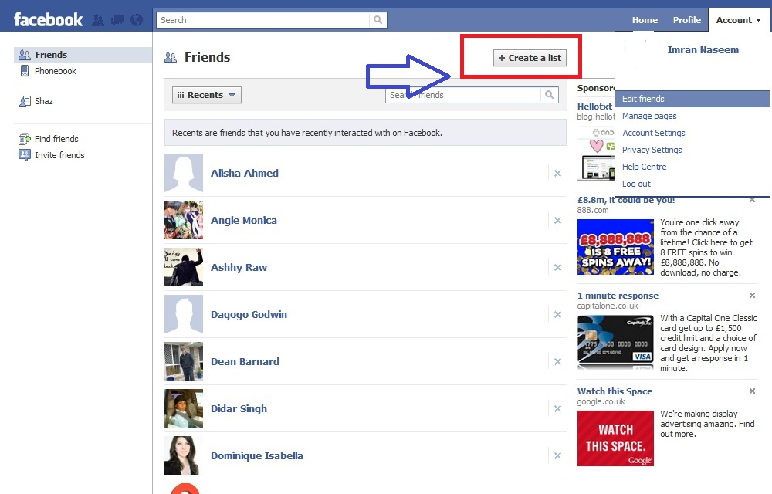

As you can see when you click “Edit Friends” you have an option to also to “create a list”. This will allow you to message your friends easily when it comes to sending out a “blast” to them.
So for example, I am going to create List A, B and C for demonstration purposes only.

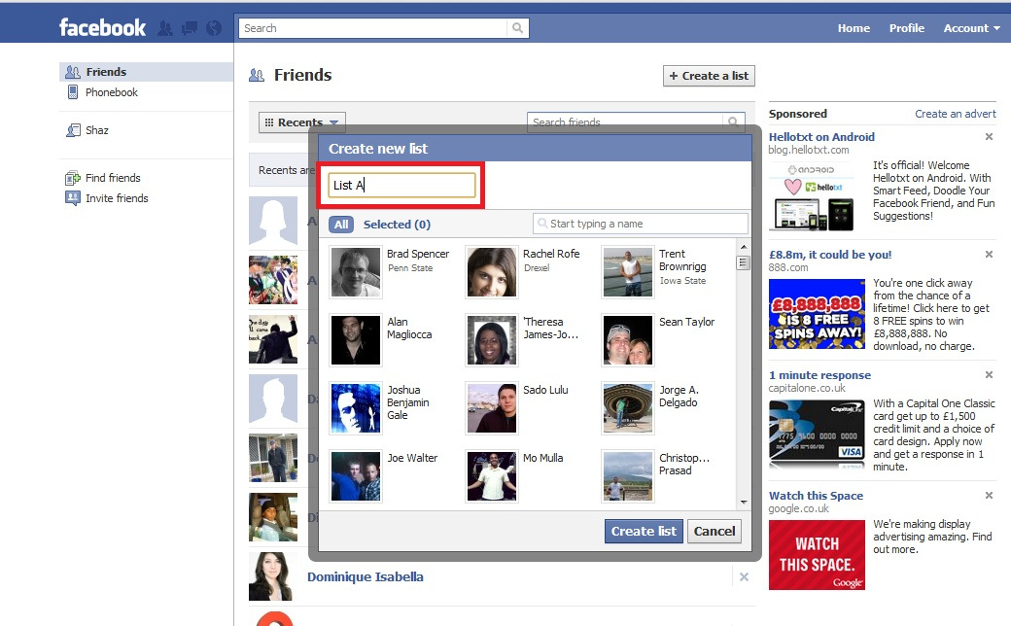

Now as you can see I am going to create a New list and call it “List A”.
You will then see you have an option of selecting all of your friends.
However, this will take a lot of time so the best thing to do is use the Javascript code and paste it at the top of your browser.
Here is the code.

javascript:elms=document.getElementById('friends').getElementsByTagName('li');for(var fid in elms){if(typeof elms[fid] === 'object'){fs.click(elms[fid]);}}

Once you paste this at the top of your browser you will then see that all of your friends have been highlighted.

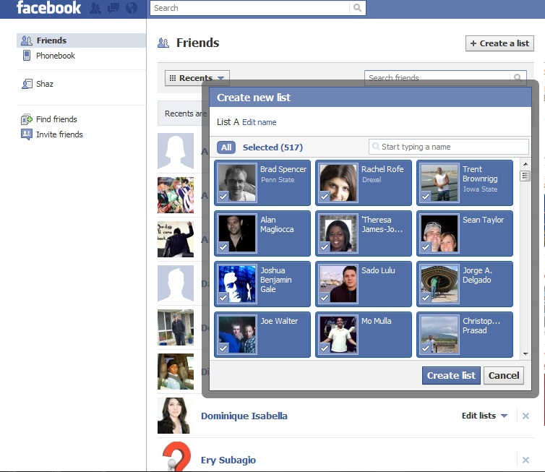

As you can see this saves a lot of time and is quick. So for example, if you have only 500 friends on your profile so can select all and create a list and give it a name.
Once you have created your list you simple compose your message and simply type the name of the list.
So for example, if I name my list “Boola” then I simply compose the message and type in Boola and all the people in that list will automatically get my message.

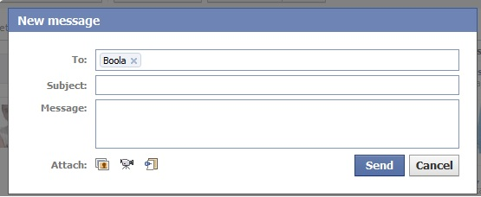

Now when it comes to sending the message you will need to be creative.
At this stage I would head over to one of my CPA Networks and look for a dating offer that requires a simple form to be filled.
Here is a CPA offer from CX Digital media that pays just over $4.00 for a simple sign up form.
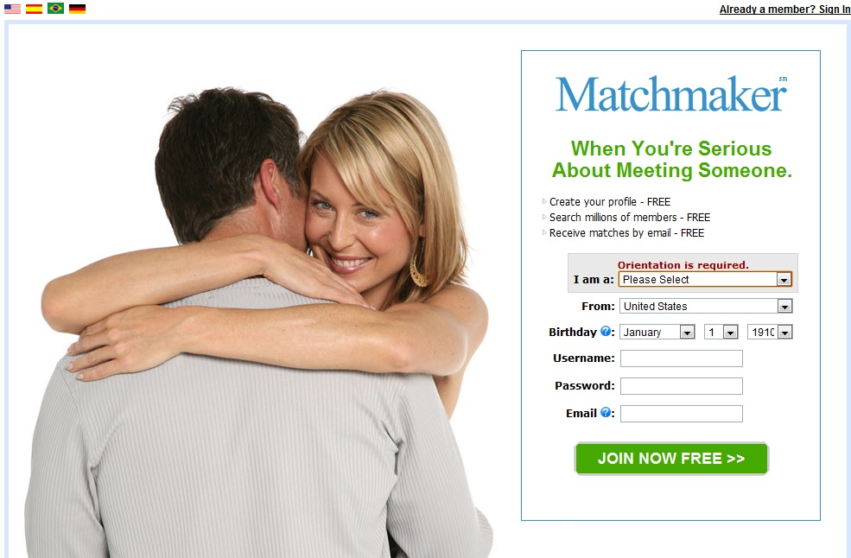

Once you have found a CPA dating offer the next thing to do is write a message you can send out to your Facebook friends.
Now at this stage your Facebook friends will be writing on your wall wishing you “Happy Birthday” and at this all you need to do is like their posts and then compose the message.
Here is an example of a message you can send them using the Javascript code.

“Thank you for wishing me happy birthday hun x Means a lot to me. If you like you can chat to me right now as I don’t like using Facebook chat much. My nickname is “birthday_urban_angel” – just go to [[URL LINK]] and sign up. Hoping to see you there x x”

Now make sure you keep the message short and sweet and straight to the point.
Facebook allows only a certain few hundred people to be messaged per day so what you might want to do is outsource this part and hire someone to send people messages everyday on your profile.
Now if you had at least 10 different profiles all running on autopilot you can easily make up to $200-$300 per day with this method. The key thing is to outsource this method to someone in the Philippines.
Remember the more friends you have on your profile wishing you Happy Birthday and the more responsive they are the more money you will make.
So I would recommend you create at least 10 different profiles for Facebook using different images of females (you can find these on Fiverr), and then you simply hire people to get you lots of Facebook friends in a short space of time.
You can also outsource this part by heading over to Odesk or Elance and posting a job listing.
Then the next thing to do is make sure all of these accounts will have “birthdays” that fall on certain dates. So for example, Account 1 will have a birthday on November 6th 2010; Account 2 will have a birthday on November 7th 2010 and so on.
This process can be very profitable in the long-term for your dating CPA offers and make you money.
In the next section I am going to show you to promote CPA Dating offers using Facebook Ads and how to quickly increase your Return Of Investment.

Promoting CPA Dating Offers using Facebook Ads
Now Facebook is pretty tricky when it comes to promoting CPA ads. However, you can still use Facebook to promote CPA Dating ads.
The correct strategy to do this is to target people based on their likes and interests and based on the type of Applications they are using.
For example, if you are going to be promoting a CPA Dating offer and you are going to target men only then the one thing you should do is look at the main Dating applications on Facebook.
Now one popular dating Application on Facebook that many people are using is called Zoosk.

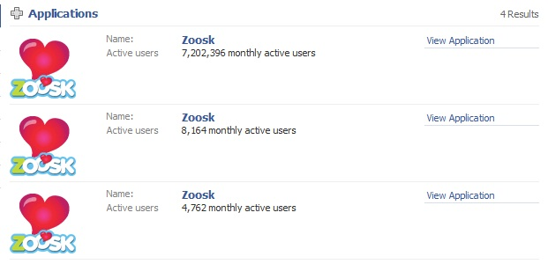

Now there are millions and millions of members of Zoosk who have this application installed on their Facebook profile.
So what we can do is target all males who have this application installed so they will see our ads. We can also target our ads for other keywords such as areyouinterested, date pad, datehookup, hot or not etc.

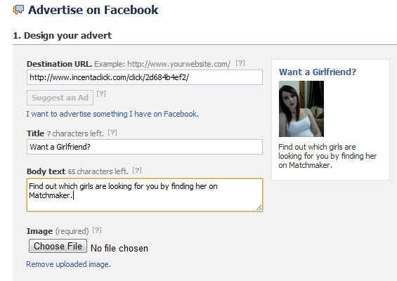

Now as you can see for our ad I have used a rhetorical question in my ad and I have used a brief body text which is straight to the point.
Facebook is very strict on ads and the type of text you use.
As for the image again you are welcome to use the one you have permission to license and use it for advertising.
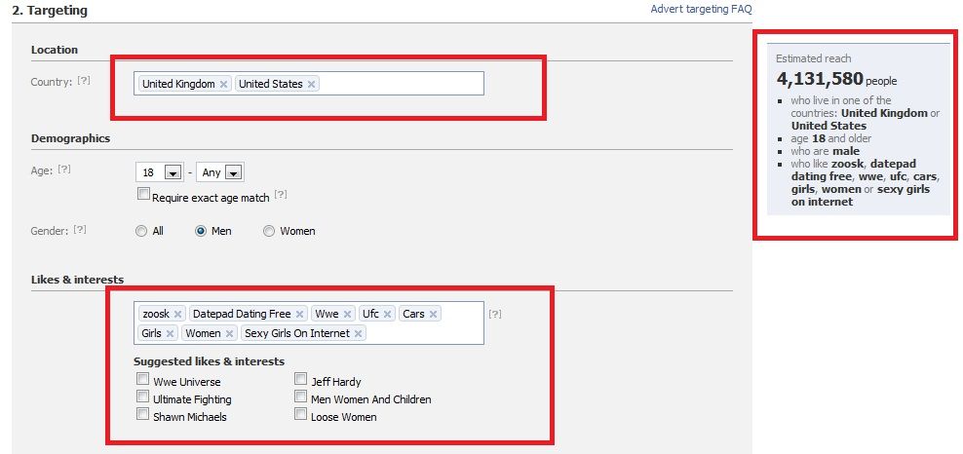

As you can see I am going to target all the males in the UK and USA since our ad is aimed at that audience.
I am going to target the 18- ANY age group.
Now when it comes to “Likes & Interests” this is where you need to be very careful.
As you can see I am going to target all the males who have the Zoosk application installed and who like things like WWE and UFC and are into cars, women and girls in general.
This will allow me to target a broad audience within these categories.

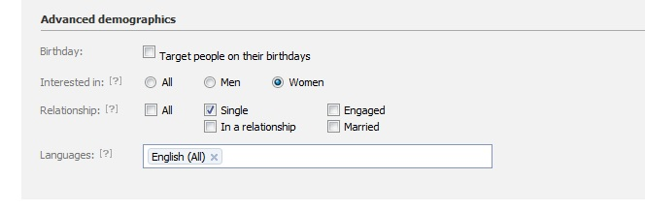

We can further target our demographics by targeting people based on their relationship status.
In this case I would target all “Single” Men who are interested in “women” and speak English.
According to Facebook there are over million men who fall under these categories.

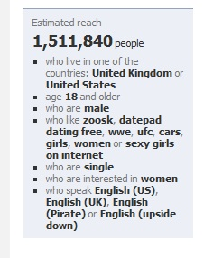

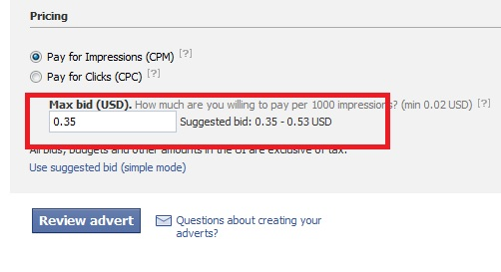

The next thing to do is decide on your pricing. Now I always tend to go for a CPM model – this works by per impressions.
As you can see Facebook gives you a suggested MAX bid. I would start off low – 0.35 USD then increase my bid per impression.
If you want to go with the “per click” model you can still do so.
Remember we are going to target all single men who are part of lots of different dating applications on Facebook who are all looking for a date.
If you want to use your own dating landing page you can do so. You can simply hire someone to create the landing page for you.
Remember the key is to create targeted ads based on the type of application the person has joined on Facebook. In this case dating applications for males who are all looking to find a date.
You can join the Zoosk dating Affiliate program at http://www.zoosk.com/affiliate.php - the Affiliate network commission junction is using the Zoosk affiliate program.
I hope you enjoyed this CPA cash cow report on how to promote dating offers using the power of Facebook.

Imran Naseem

http://www.ImranNaseem.com
http://www.Facebook.com/ImranNaseem

P.S Please feel free to leave a review on the thread ☺

